**The Battle of Neighborhoods**[**¶**](http://localhost:8888/notebooks/The%20Battle%20of%20Neighborhoods%20-%20Week1.ipynb#The-Battle-of-Neighborhoods)

**Looking for places in England to start a Bandeoke business**

# **Introduction (Business problem)**

England has been the cradle of diverse artists and bands that have changed the musical scene worlwide. From psychedelic to indie, passing trough progressive and punk, british music has contributed to a great variety of styles and still has a great influence in present mainstream and underground scene. That's why music lovers arrive every year to visit historical music places, go to concerts and enjoy nightlife.

But, what are the musical preferences of every city in England? This has been drafted by identifying the outstanding artists and bands in every city and finding their musical style.

This would help tourists keen on music to choose the best cities to visit, event promoters to set the city to organize a concert or entrepreunors to select the best place to start a business on music.

For this project purposes, I'll focus on the point of view of an entrepreunor who is looking for the best place in England to start a Bandeoke business pointed to eighties and nineties popular rock music (post-punk, new wave, alternative and indie).

To help this entrepreunor, the city where these musical styles are prefered is found. Next, the areas in this city are explored to choose the best to set the location of the Bandeoke.

# **Data**

**Music data**

As datasets on musical preferences in England weren't found in any data repositories, the musical taste was deducted from raw information about bands musical production available in these sources:

* List of outstanding music artists and bands from England[¶](http://localhost:8888/notebooks/Downloads/Capstone/Capstone%20Project%20ASUCSO.ipynb#List-of-outstanding-music-artists-and-bands-from-England)

<https://en.wikipedia.org/wiki/List_of_music_artists_and_bands_from_England>

* Genres played by bands

Information available in every band Wikipedia article.

* Supergenres (musical style)

Classification of genres available in:

<https://musicmap.info/>

**England population data**

<https://worldpopulationreview.com/countries/united-kingdom-population/cities/>

**Neighborhoods in Manchester data**[**¶**](http://localhost:8888/notebooks/Downloads/Capstone/Capstone%20Project%20ASUCSO.ipynb#Neighborhoods-in-Manchester-data)

* List of areas in Manchester

<https://en.wikipedia.org/wiki/Category:Areas_of_Manchester>

* Manchester areas data

Information available in every Manchester area Wikipedia article.

# **Methodology**

* 1. **Exploratory data analysis on musical production**

To start with, some search was made on datasets or raw information about musical tastes in England by city, with no satisfactory results. However, musical production was considered a good indicator of musical tastes.

Regarding this, raw information about outstanding bands of different popular musical styles in England was found in Wikipedia. These bands were classified by city origin but lacked of information about genres played. To overcome this, every band article available in Wikipedia was explored to get the genres played by the band.

Once the dataframe of oustanding bands with their genres played was obtained, another mishap was faced. Genres played by bands on the whole, were very diverse, what it made it difficult to classify the style bands. So, a grouping of genres into supergenres was made using the classification achieved in Musicmap.

Finally, for each band the styles (supergenres) played were identified and a final dataframe of bands, origin city and style played was obtained. The procedure is described onwards.

1. **Outstanding bands in England by origin city**

A list of notable music artists and bands from England, by origin, is available in the next link in Wikipedia:

<https://en.wikipedia.org/wiki/List_of_music_artists_and_bands_from_England>

Every band is linked to its respective article in Wikipedia as it’s shown in the image:

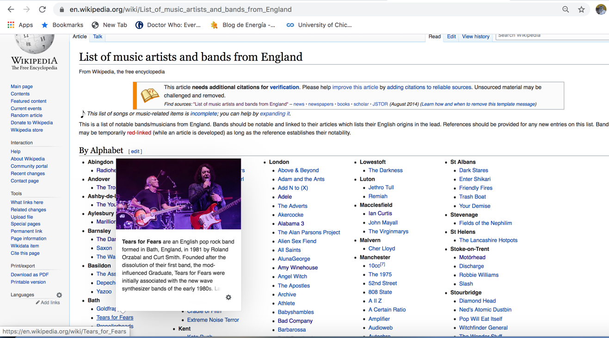

The link above was scrapped using the Beautiful Soup package, to extract not only the bands and artists with its respective origin, but also the Wikipedia page each band and artist is linked to. In the image below, there is an extract of the dataframe obtained:

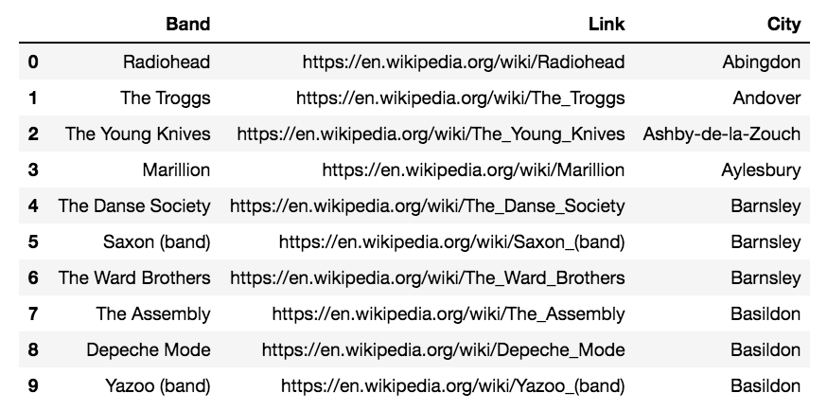

1. **Music artists and bands’s musical genres**

Every article URL to which the name band is linked to, has background information containing the musical genres played by the band.

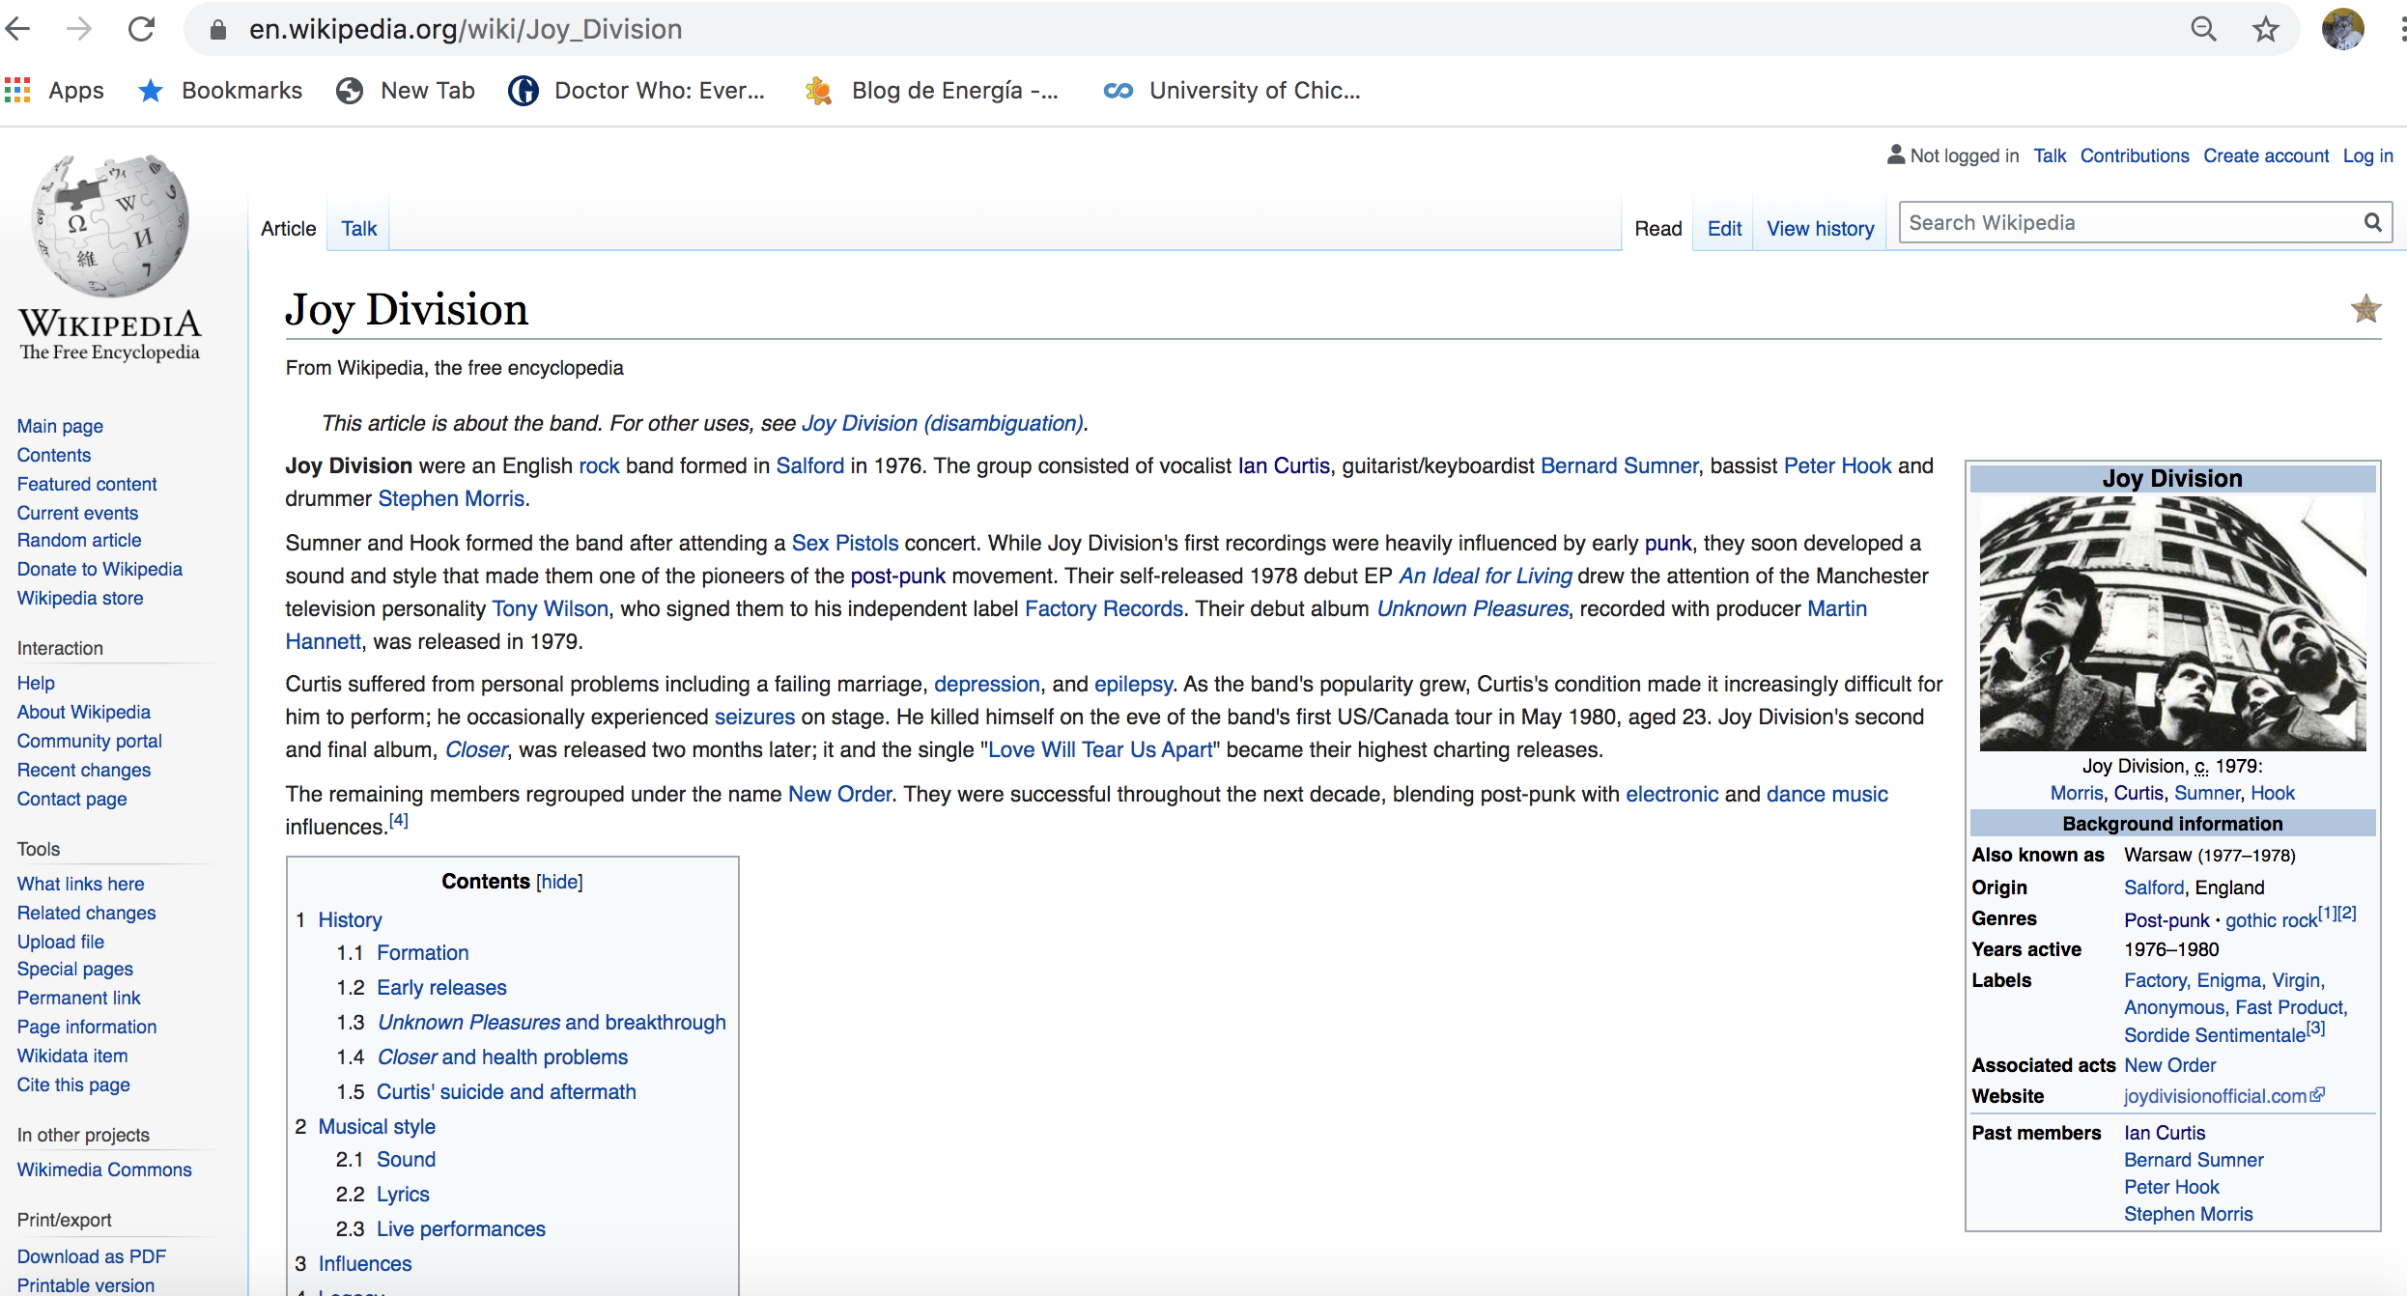

So a function to scrap every band URL, using Beatiful Soup, was defined to extract at most six genres played by each band. This is an extract of the resulting dataframe:

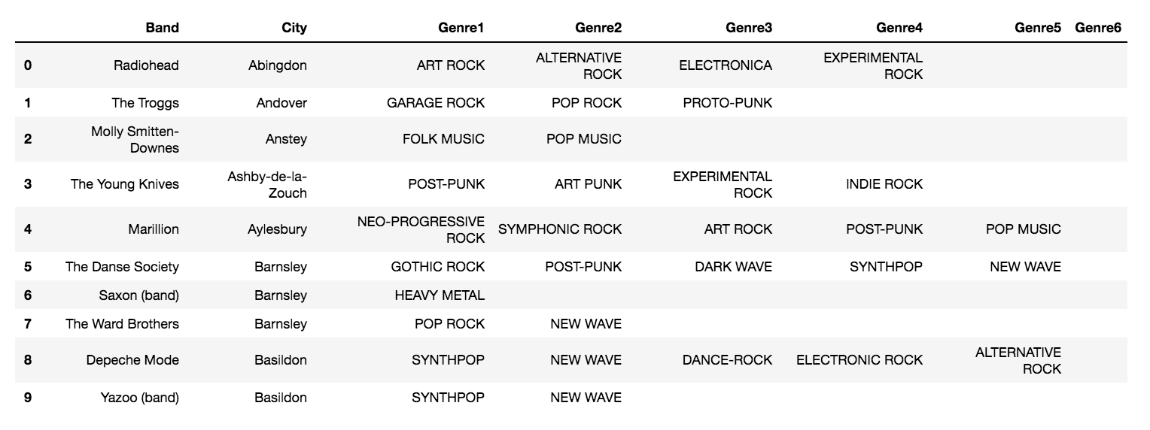

1. **Grouping the genres into supergenres**

As it’s shown in the dataframe above, a band can play several musical genres, and each genre can pertain to different styles or musical trends. This results in a great variety of genres played between all bands, what makes it difficult to manage the data. To overcome this, a grouping of the found genres into supergenres has been carried out, taking into account the great work made in Musicmap, where a classiffication has already been made:

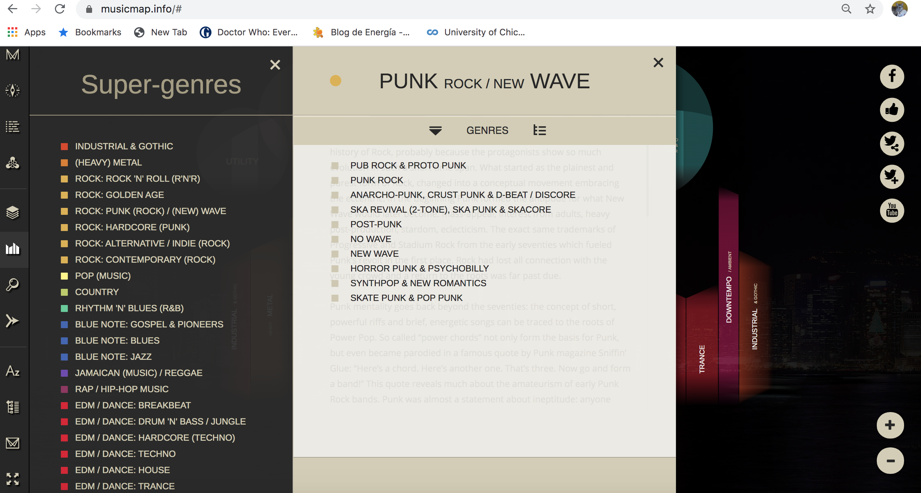

For this project purposes, only the grouping of genres related to popular music have been considered. So, this is the dataframe of supergenres considered:

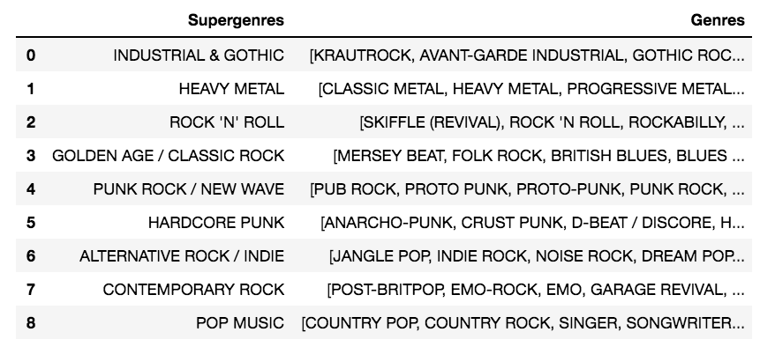

1. **Finding the supergenre every band's genre pertains**[**¶**](http://localhost:8888/notebooks/Downloads/Capstone/Capstone%20Project%20ASUCSO.ipynb#d)-Finding-the-supergenre-every-band's-genre-pertains)

A function was created to get the supergenre every genre is in, giving this resulting extract:

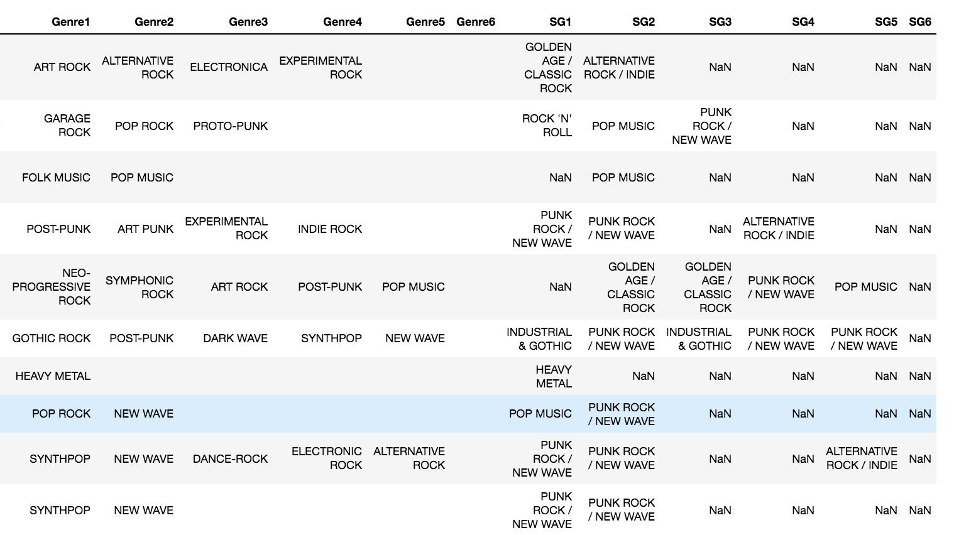

1. **Summarizing supergenres played by band**

In the extract above, once more it’s seen that some bands have tried different genres. In some cases, these genres belong to a unique supergenre, but in other cases, these genres belong to different supergenres. To better visualize this, the categorical supergenre columns have been converted to dummy variables:

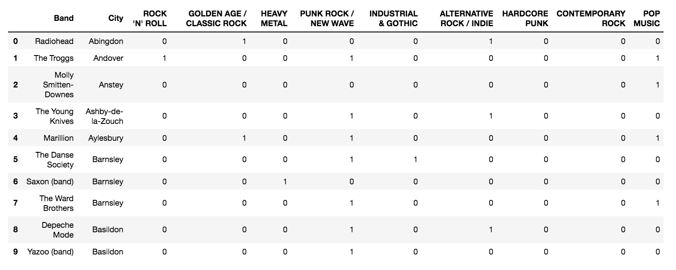

Now, the dataframe ready to analyze.

* 1. **Analyzing musical production**

1. **Musical production**

From the dataframe constructed, the cities with more outstanding bands are showed in the image below, where London and Manchester are the most productive.

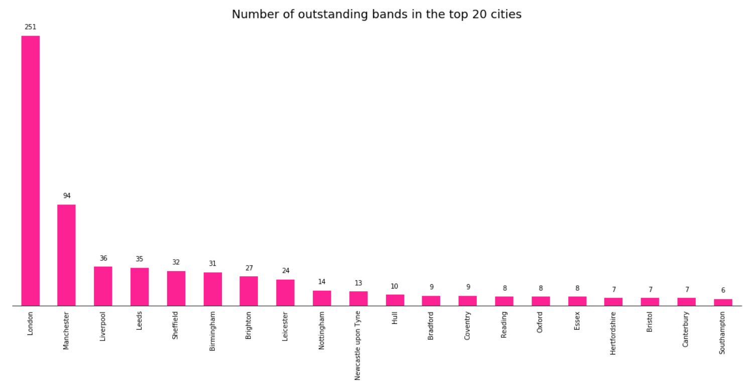

1. **Top styles produced by city**

For each city, the style percentage participation is calculated and coloured according to its value. As it’s shown, the ‘ALTERNATIVE ROCK / INDIE” style is the most produced for the majority of cities.

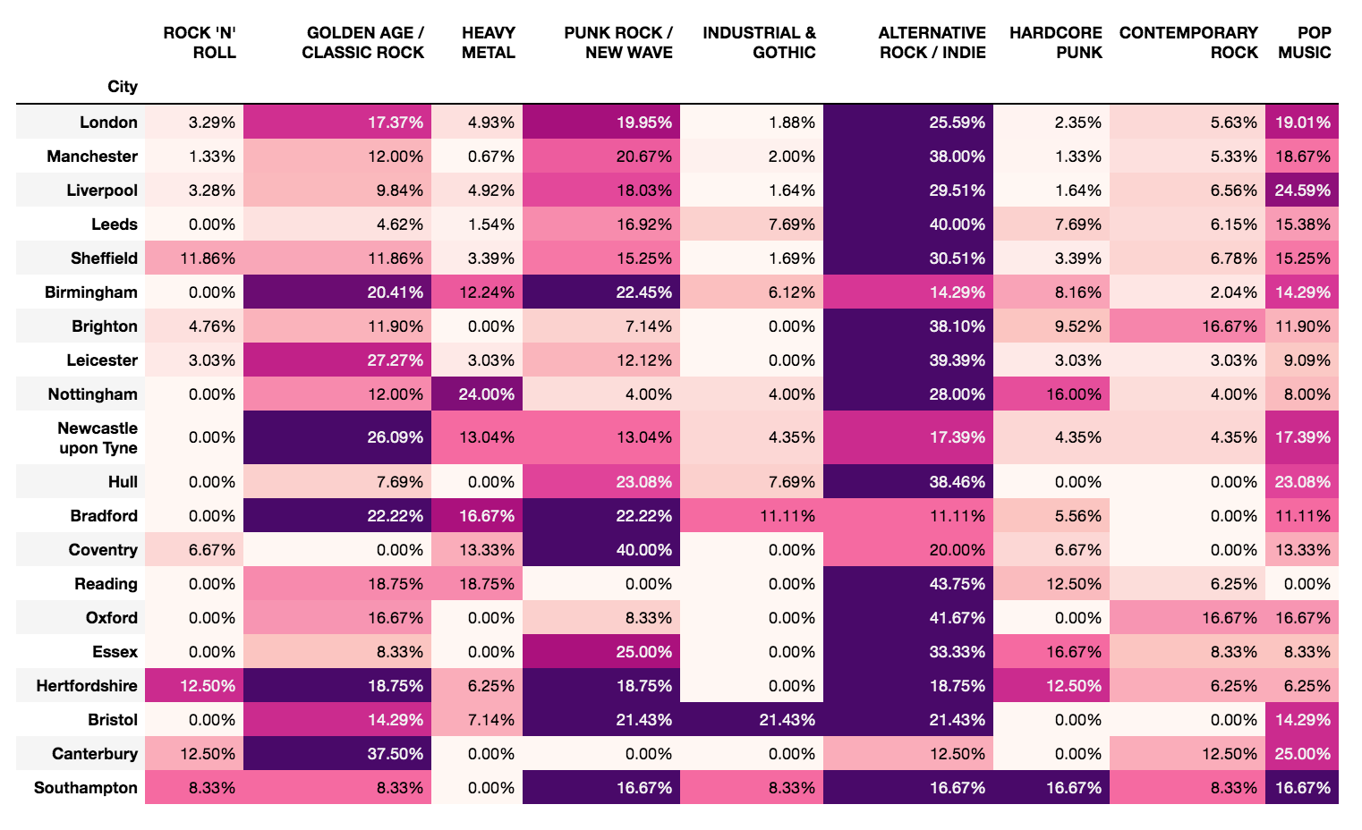

1. **Cities where the style is most produced in**

London is the city that outstands in production for every style. This was expected as London is by far, the most populated city in England.

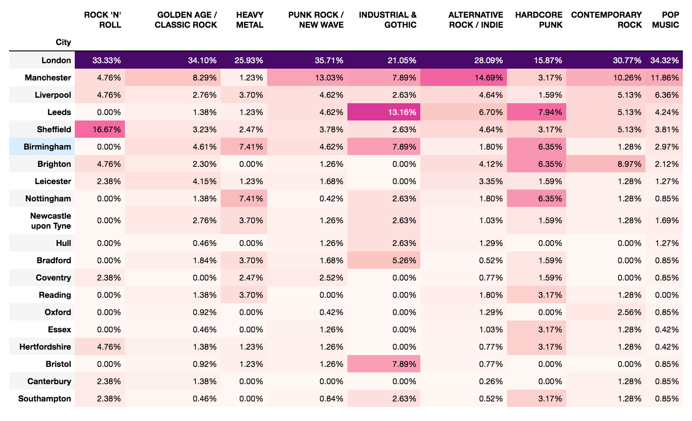

* 1. **Analyzing musical production density**

In the analysis above, London outstanded in musical production mainly because of its population. In this section, population is taken into account to analyse how intense in terms of population density is the musical production. To that, the musical production by every 100,000 city habitants is showed in this extract.

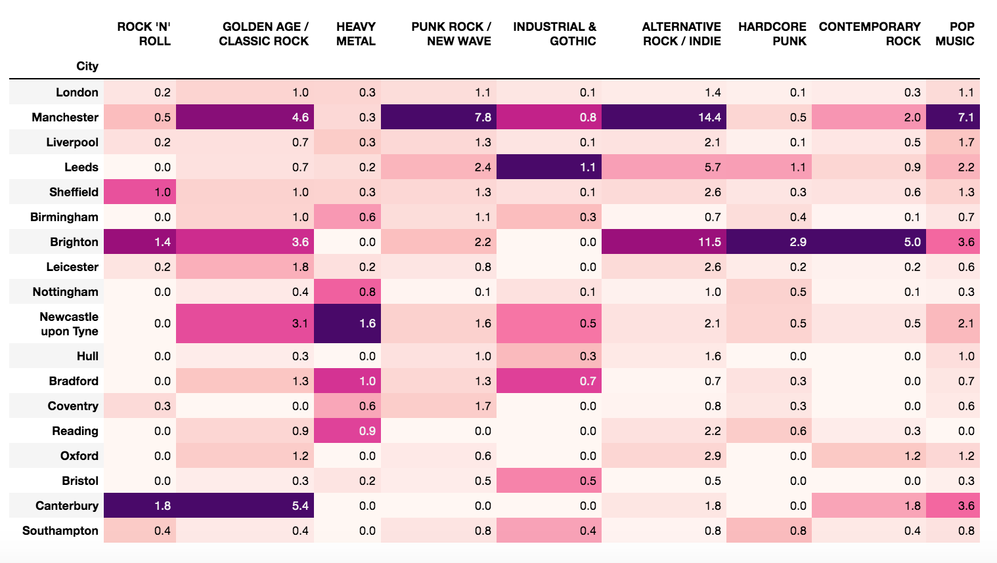

Now, it's seen that actually, Canterbury outstands in musical production of 'ROCK 'N ROLL' and 'GOLDEN AGE / CLASSIC ROCK', Newcastle upon Tyne in musical production of 'HEAVY METAL', Brighton in musical production of 'HARDCORE PUNK' and 'CONTEMPORARY ROCK', Leeds in musical production on 'INDUSTRIAL & GOTHIC'. Finally, Manchester outstands in production of 'PUNK ROCK / NEW WAVE', 'ALTERNATIVE ROCK / INDIE' and 'POP MUSIC'!

From these results, we can infere the musical tastes in England. For 'PUNK ROCK / NEW WAVE' and 'ALTERNATIVE ROCK / INDIE', Manchester is the most productive, so it can be said that this is the city where these styles are the most prefered.

For these reasons, it's concluded that Manchester is the best city to start a Bandeoke business aimed to people keen on 80s and 90s music, where punk rock, new wave, alternative rock and indie rock were very popular.

* 1. **Exploring areas in Manchester**

In the analysis of musical production, Manchester was found to be the best place to start a Bandeoke business aimed to people keen on 80s and 90s. In this section, Manchester areas are explored to define the best to locate this Bandeoke.

To this, information about areas inside Manchester and their coordinates were extracted from articles available in Wikipedia.

Next, using Foursquare, every Manchester area was explored in search of music related venues. After this, the frequency of music related venues and the top ones are identified for every area. This leaves the areas ready to be clustered.

1. **Getting areas data**

In the next URL from Wikipedia a list of areas in Manchester is given. From this list, it was obtained the areas, and from the articles in Wikipedia about them, their coordinates, everything, by using Beautiful Soup.

<https://en.wikipedia.org/wiki/Category:Areas_of_Manchester>

This is the resulting dataframe:

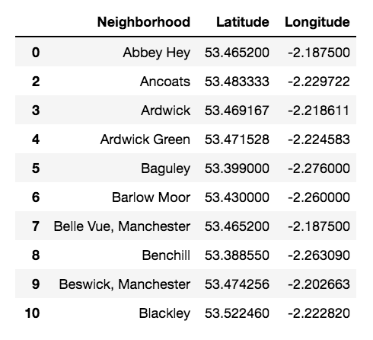

The areas in Manchester are located in this map:

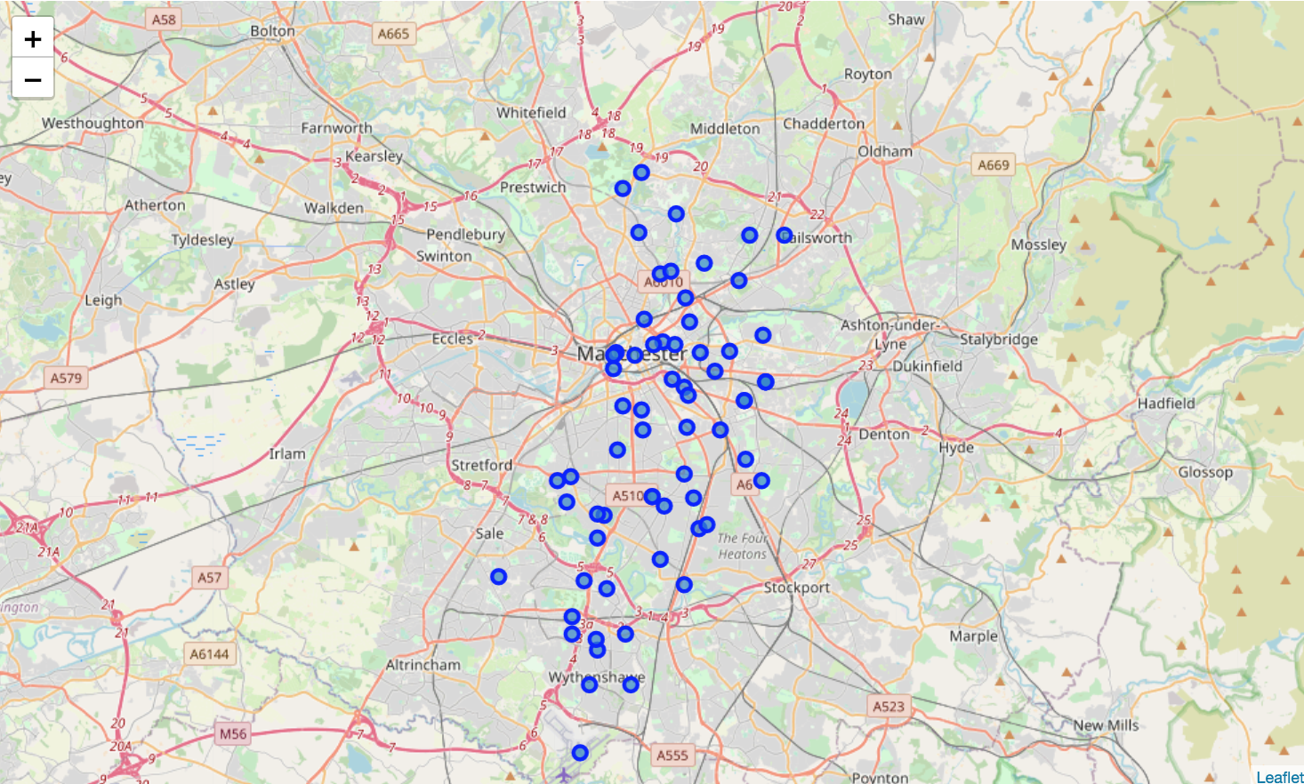

1. **Exploring areas in Manchester**

**Venues categories considered**

As it was pointed in the business problem, the final goal project is to set the best location to start a Bandeoke business. For this, areas in Manchester are explored using Foursquare, in search of music related venues. Regarding this, Foursquare has venues classified by category; this classification and identificators are available in this URL:

<https://developer.foursquare.com/docs/build-with-foursquare/categories/>

These are the venues related music categories considered:

|  |  |
| --- | --- |
| Venue category | Identificator |
| Music venue | 4bf58dd8d48988d1e5931735 |
| Jazz Club | 4bf58dd8d48988d1e7931735 |
| Piano bar | 4bf58dd8d48988d1e8931735 |
| Rock club | 4bf58dd8d48988d1e9931735 |
| Music Festival | 5267e4d9e4b0ec79466e48d1 |
| Nightlife Spot | 4d4b7105d754a06376d81259 |
| Music School | 4f04b10d2fb6e1c99f3db0be |
| Music Store | 4bf58dd8d48988d1fe941735 |
| Record Shop | 4bf58dd8d48988d10d951735 |
| Recording Studio | 52f2ab2ebcbc57f1066b8b37 |
| Concert Hall | 5032792091d4c4b30a586d5c |
| Amphitheater | 56aa371be4b08b9a8d5734db |

**Foursquare calls**

A function to create API calls for specific venues categories was created.

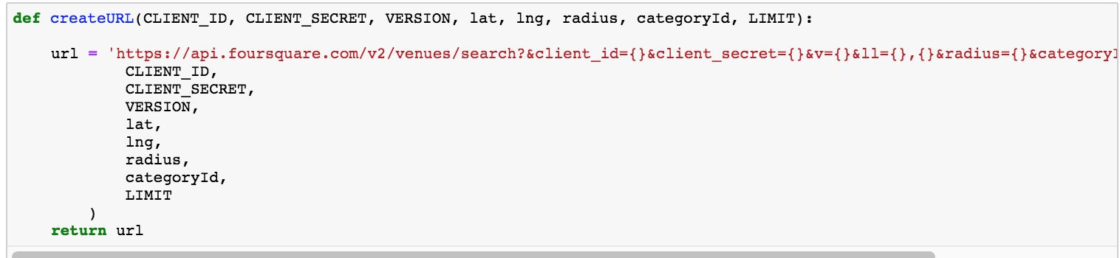

This is a function to retrieve music related venues for every Manchester areas:

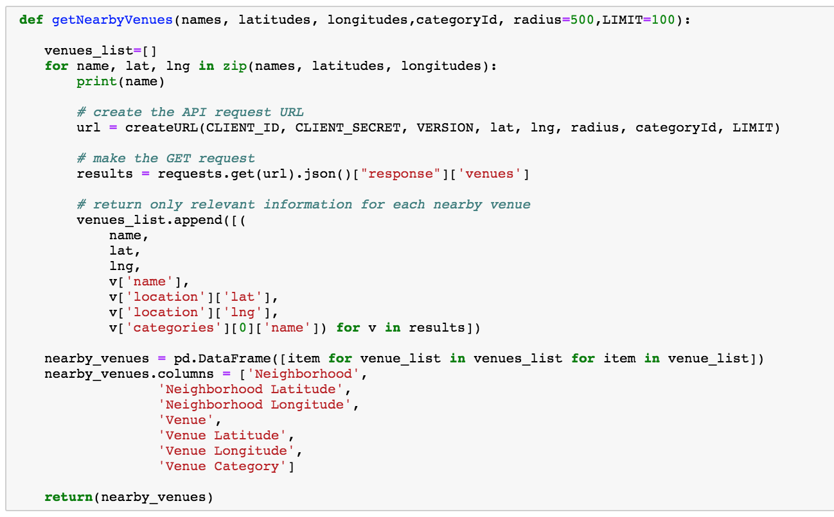

**Venues retrieved**

This is a sample of the music related venues retrieved for every Manchester area:

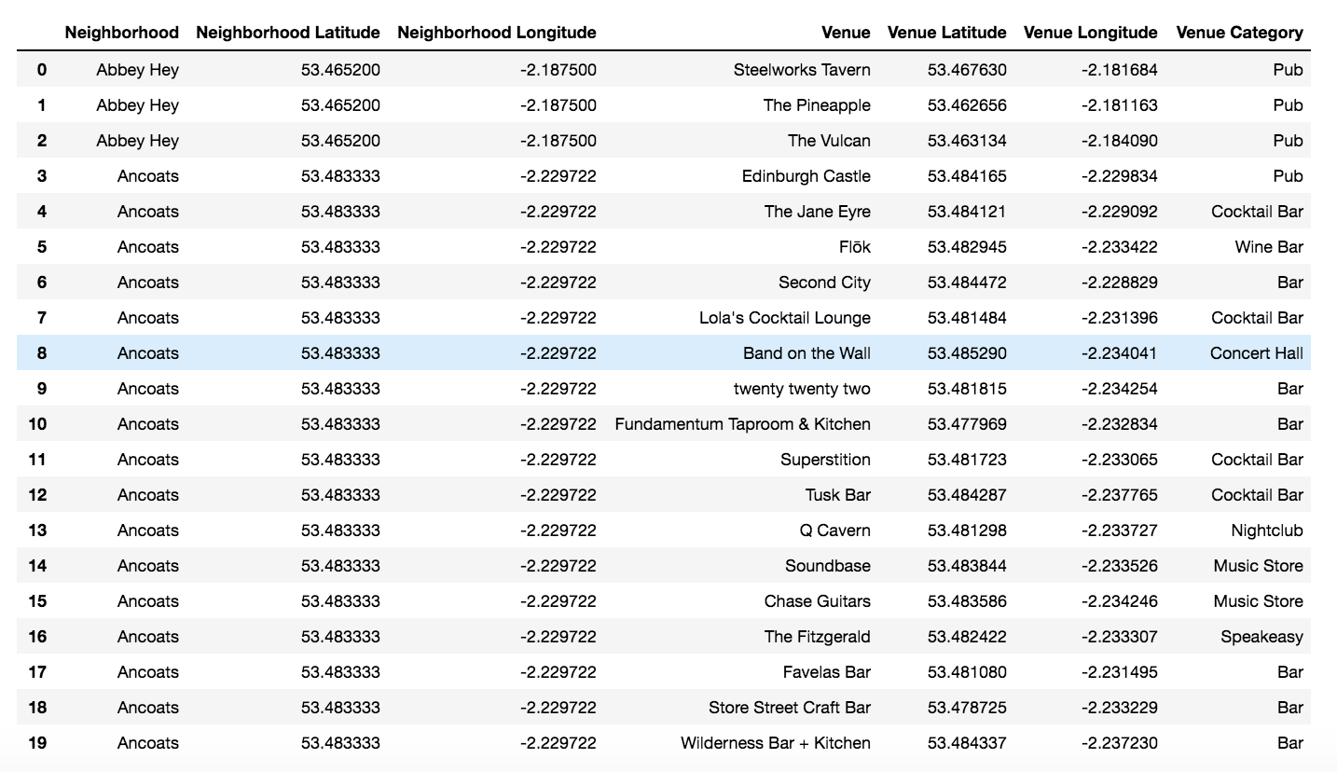

**Popular venues categories**

To find similar areas based on existing musical venues, a one-hot encoding is applied to each category venue.

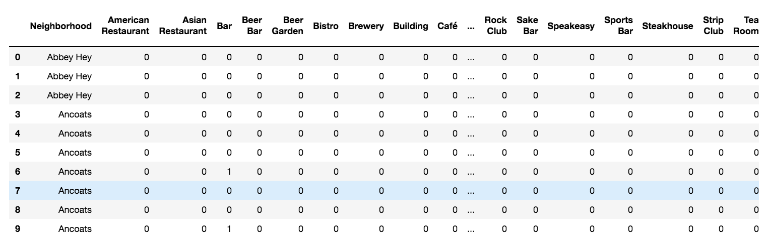

For each area, the frequency of ocurrence of each venue category is found by getting the mean.

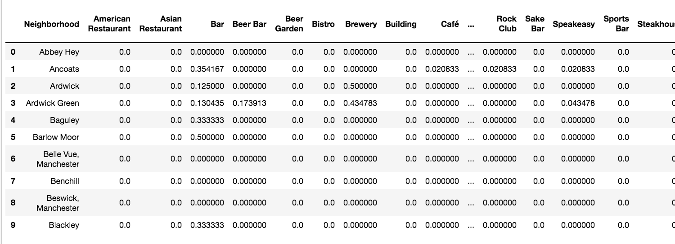

Taking the value means of each venue category, the 10 most common venue categories are found:

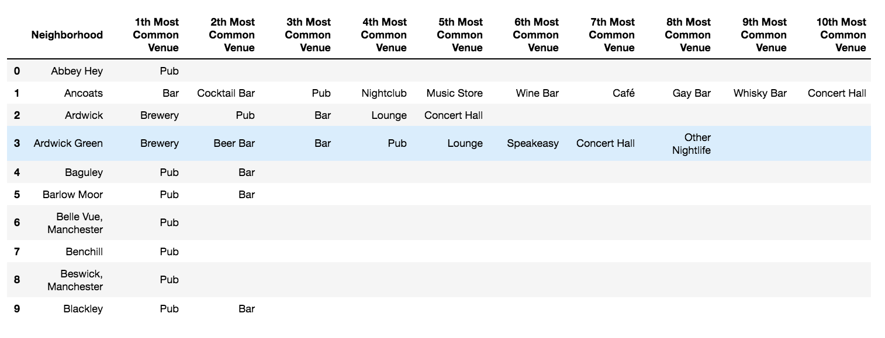

* 1. **Clustering areas in Manchester**

Areas in Manchester are clustered, in 5 groups taking into account the frequency of occurrence of the venues categories. This is a sample of the results dataframe of the clustering.

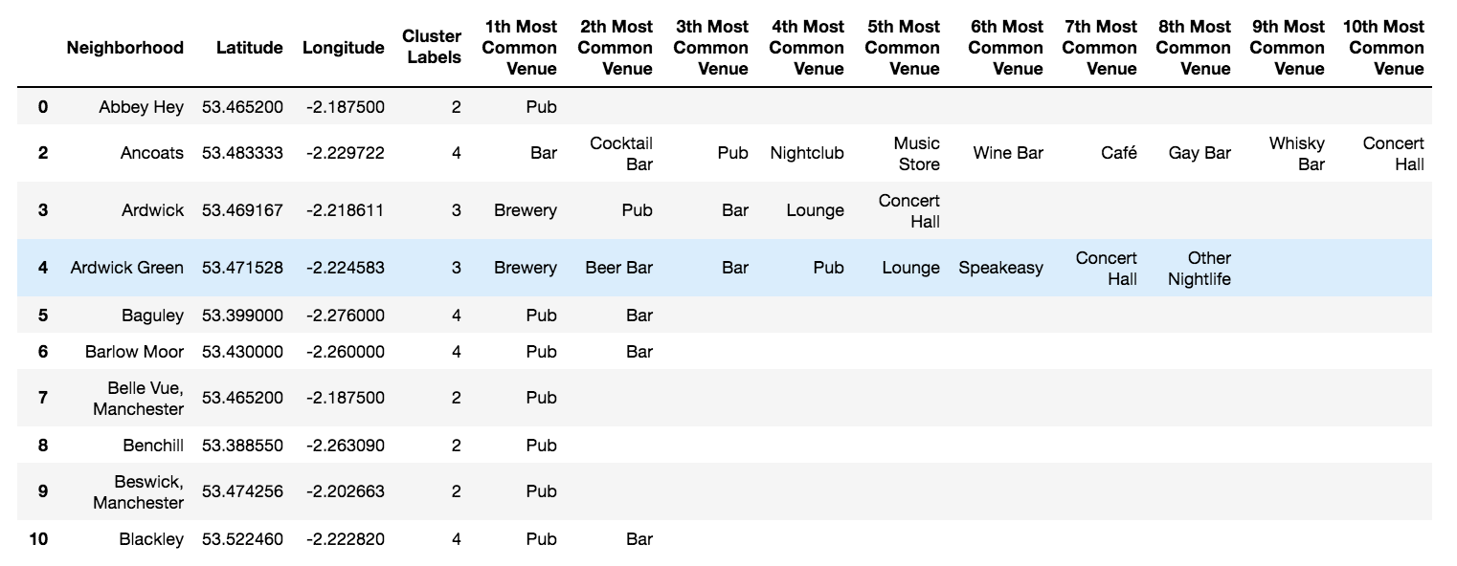

# **Results**

**Clusters visualization**

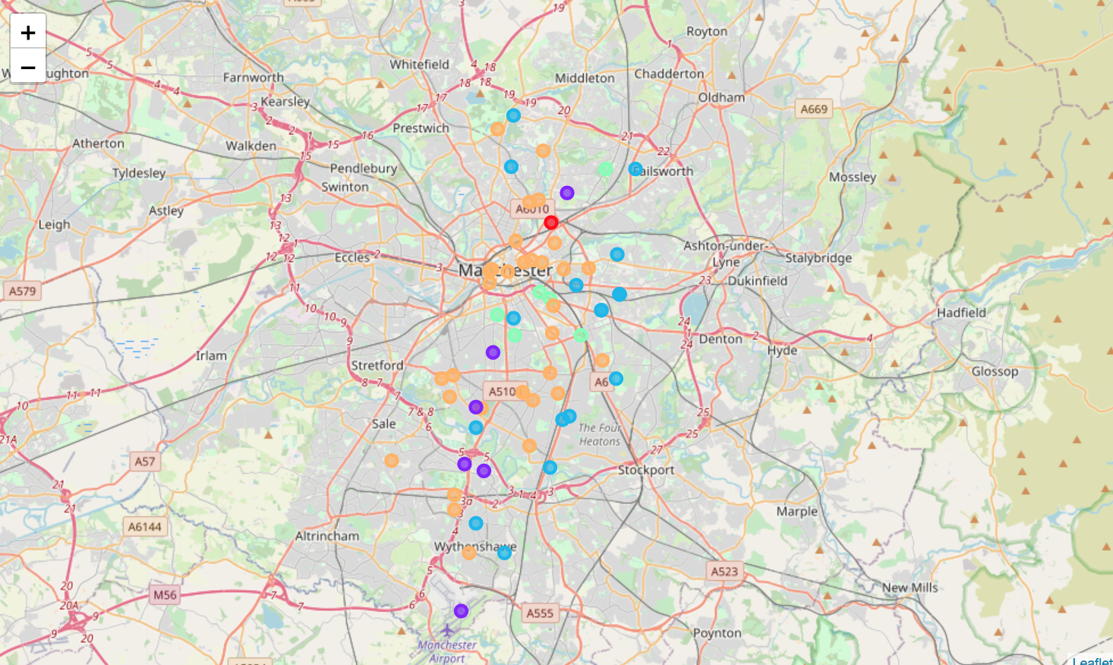

**Clusters analysis**

In the areas exploration, venues searched for were all about music, so every cluster is characterized for having some kind of venues related music categories. But besides that, the grouping has somehow classified the degree of musical activity in the areas clustered.

This way, clusters 1, 2 and 5 are characterized for having areas with very little musical activity. In cluster 1, areas are focused on bar activities and in cluster 2 areas are focused on pubs activities. For cluster 5, the only area almost doesn't have music activity. These clusters seem to group areas with very low economic movement.

On the other hand, clusters 3 seems to encompasses areas with medium musical activity. Also, these cluster seems to group areas with medium economic movement.

Finally, cluster 4 gathers areas with high and very diverse musical movement. Besides, it seems to have high economic movement and to be very popular. In fact, the city centre is in this cluster.

Cluster 1

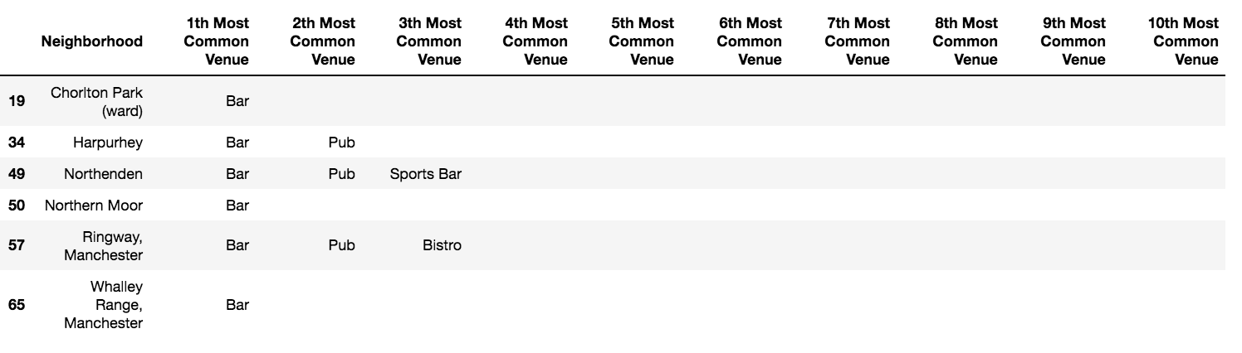

Cluster 2

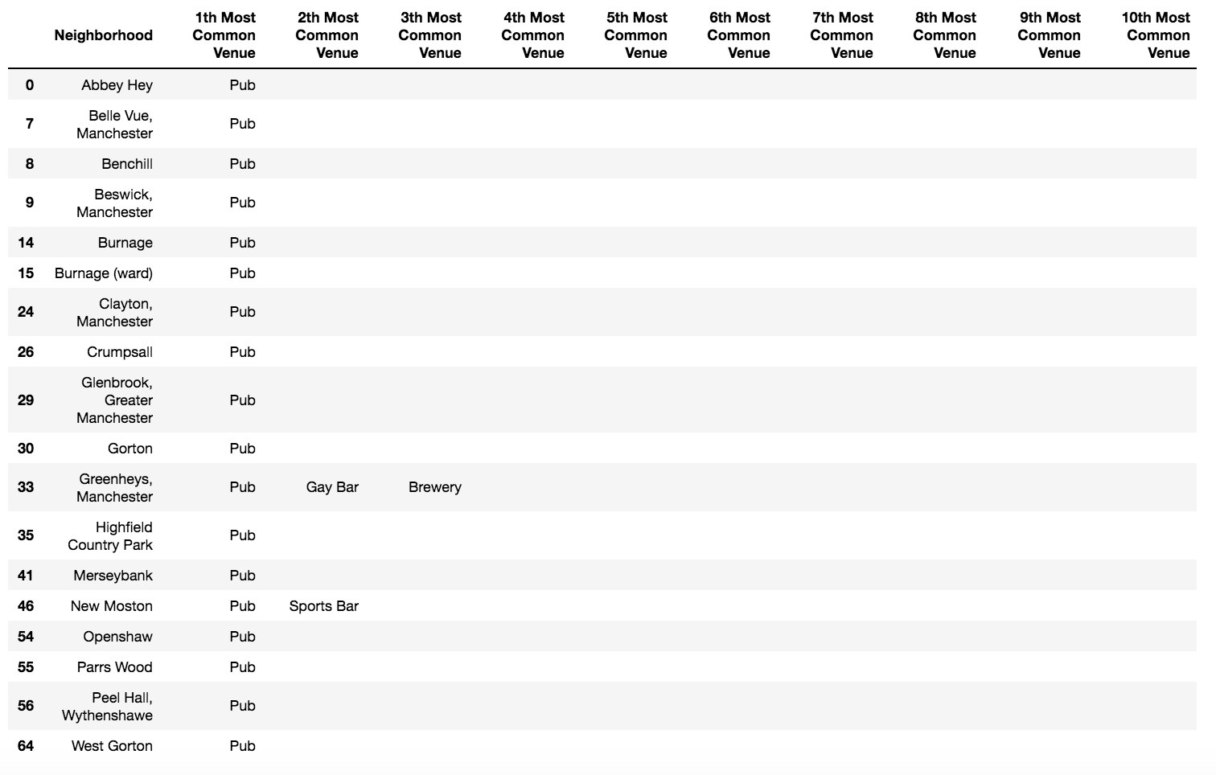

Cluster 3

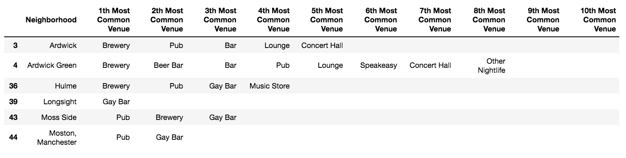

Cluster 4

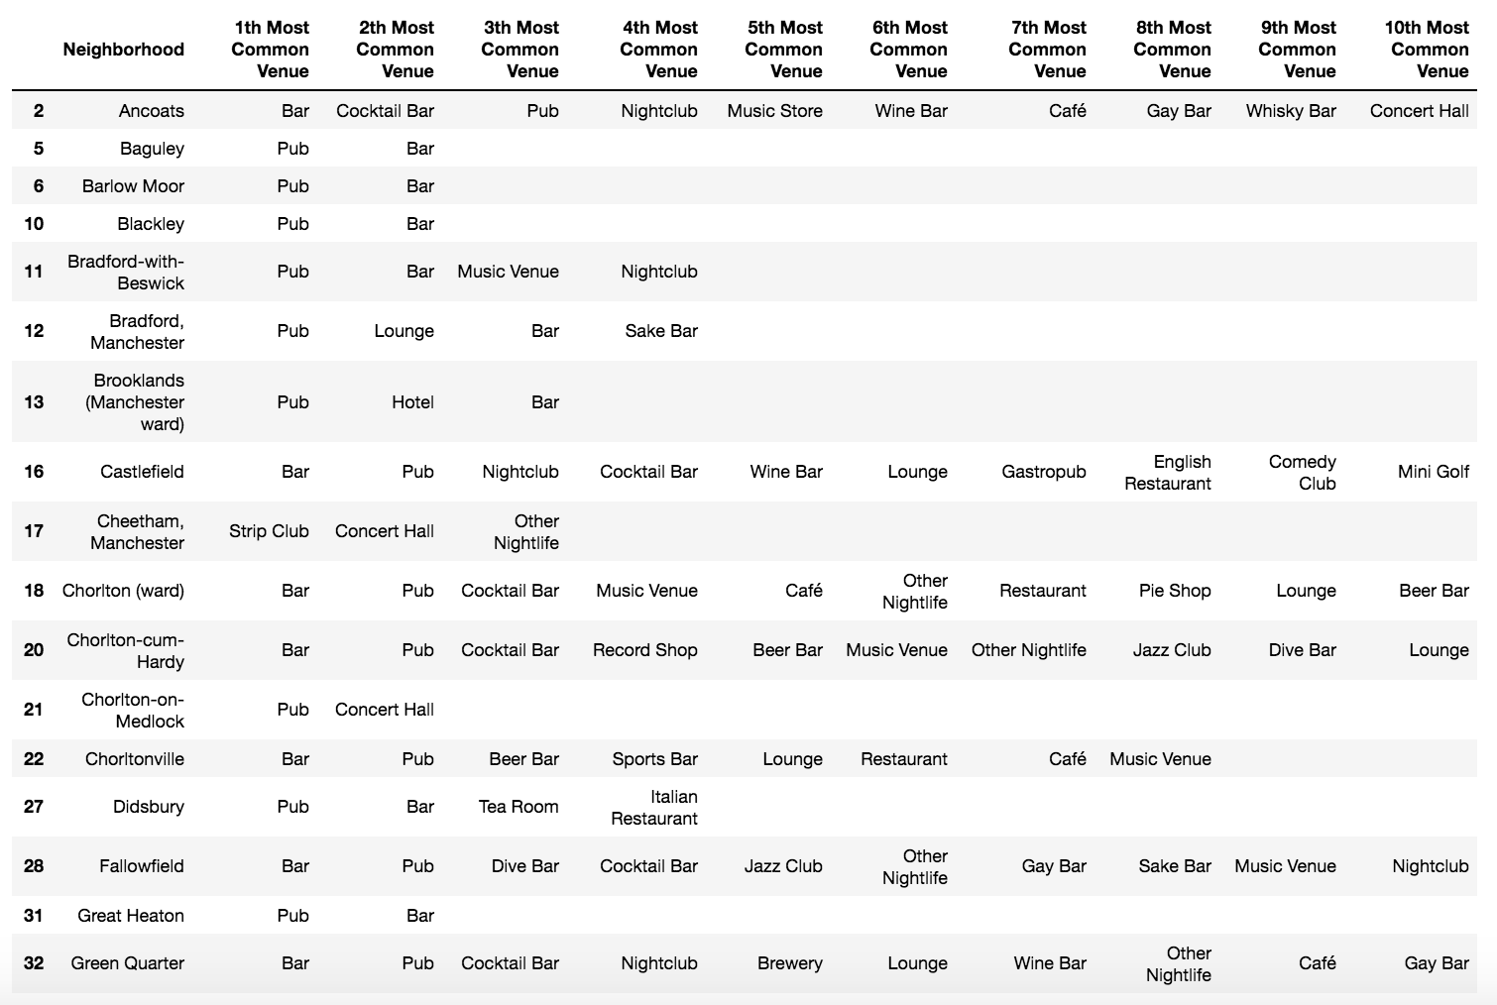

Cluster 5

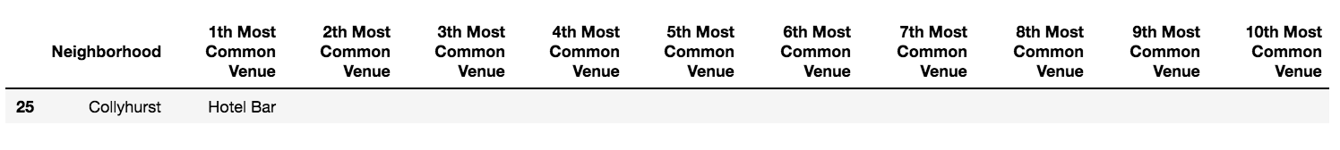

# **Discussion**

In this project, in the absence of better information, the musical tastes in England cities have been derived from their musical style production. This could be misleading, as it's a lot much easier to create songs that rarely exceed two minutes (some varieties of punk) than to create really musical masterpieces (some musical pieces of progressive rock). But virtuosity and complexity rejection is something that also must be taken into account. Some people just prefer easy-listening music, otherwise, classical music would be the popular one. For these reasons, despite some pitfalls, it can be considered that musical production is a good indicator of musical preferences, and in this sense, Manchester most prefers punk, new wave, alternative and indie rock.

On the other hand, from clusters analysis, the best areas to start the Bandeoke are those included in cluster 4. This cluster contains areas highly intense in musical movement, areas that also would be appealing for easy to singing music enthusiasts.

# **Conclusion**

Despite having found London has produced the majority of outstanding bands for every style in England, if we take the population into account, Manchester is the most productive in punk rock, new wave alternative rock, indie rock and even pop music. About this, the best Manchester areas to set the Bandeoke business are in cluster 4.

The project has been useful for analyzing the musical preferences of every city in England, but in absence of other available information, this preference was infered from the styles of bands emerged in every city. A more precise result could have been obtained if there was availability of other information such as sold disks, listened music on Spotify or watched videos on Youtube.

On the other hand, the results of the project, specially the dataset of musical genres obtained, are a great instrument to make some other analysis related to music.